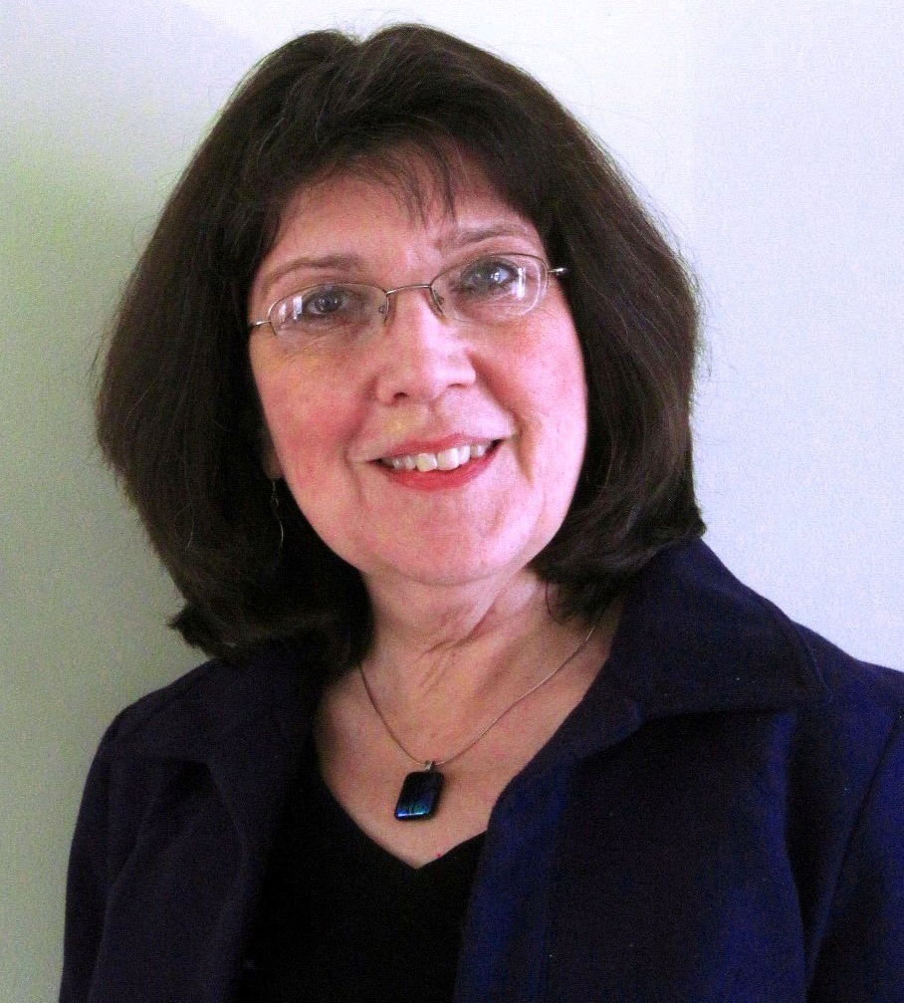

Creighton University Chapter of

Pi Theta Epsilon

Distinguished Lecturer

Carol Siebert, MS, OTR/L

CEUs available for practicing clinicians!

Email JennieOllason@creighton.edu to register for CEUs prior to March 23rd.

Presents

Claim It and Proclaim It:
Occupational Therapy Can Be One of the Great Ideas of the 21st Century

Free of charge!
Wednesday, March 26th
5:30 – 7:30 pm
Harper Center Auditorium
602 North 20th Street

Carol Siebert has over 25 years of experience in home and community-based occupational therapy. She worked as a home health occupational therapist for more than a dozen years before shifting to a practice focused on home modifications, aging in place and community health. Since 2003, she has provided services under contract with Duke University’s Division of Community Health, providing direct occupational therapy, population-based program development, and care management services. Through her practice, The Home Remedy, Carol offers aging in place consultation, home modification assessment and intervention, and training and consultation in home and community practice and policy. In 2006, she was named a Fellow of the American Occupational Therapy Association for her leadership in home health practice and advocacy.

